ES - Sprint 2 – Code Smells 3

**Duplicated Code**

This code smell occurs when blocks of code exist in the design that are similar but have slight differences appearing in multiple places in the code. If is needed to implement an update is harder to do it, so we should implement only in one location, decreasing the chance of a block not being updated.

* 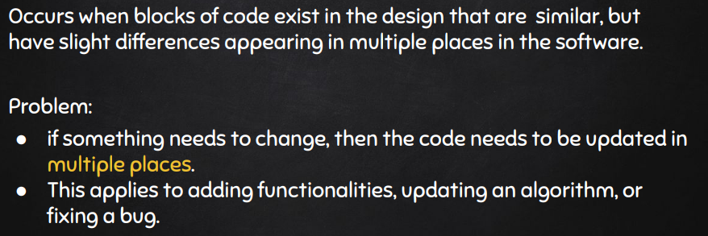**Code Snippet**

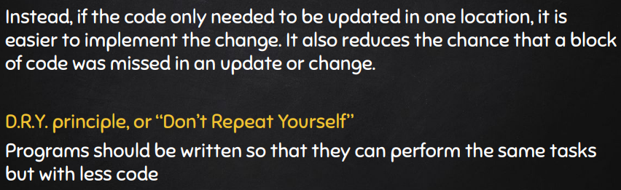

* **Code Location**

Path: *“src\main\java\org\jabref\logic\importer\fileformat\BiblioscapeImporter.java”*

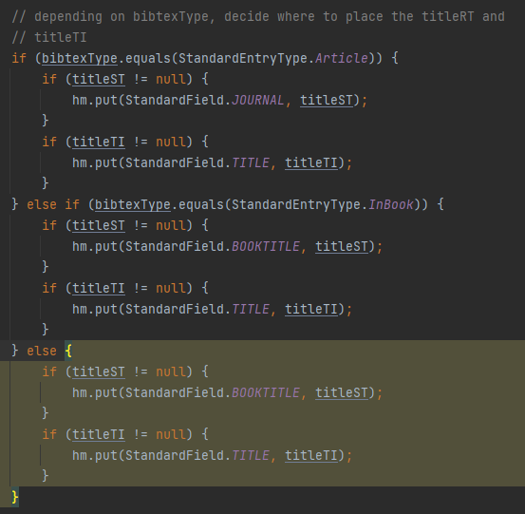

**Justification**

If we notice the following part (“if(titleST != null){ hm.put(StandardField.TITLE, titleST);}”) repeats six times during the method changing only the parameter StandardField.TITLE and titleST.

**Refactoring Proposal**

In this case we could create a private method that receive StandardField.TITLE and titleST (and the other types) as a parameter and execute what he should.

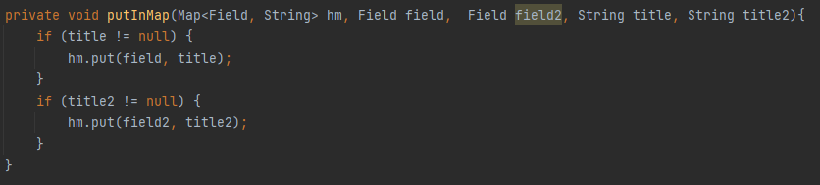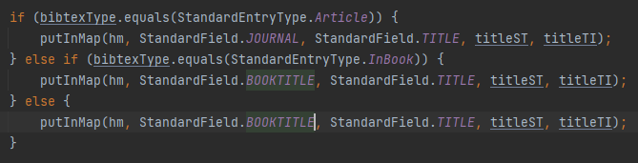The method should be: